**11.10 Normal Distributions**  
Objective: To use a normal distribution

**Normal Distribution:**

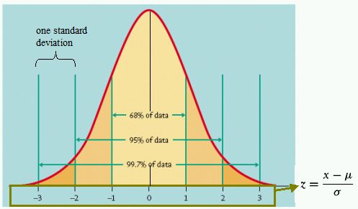

are within 1 Standard Deviation of the Mean  
are within 2 Standard Deviation of the Mean  
are wither 3 Standard Deviation of the Mean

**Examples:**

**The actual weights of bags of pet food are  
normally distributed about the mean. Use  
the graph at the right for Exercises 1–4.**

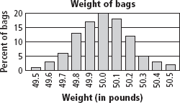**1.** About what percent of bags of pet food weigh  
49.9 lb–50.1 lb?

**2.** About what percent of bags weigh less than  
49.8 lb?

**3.** In a group of 250 bags, how many would you expect to weigh more than  
50.4 lb?

**4.** The mean of the data is 50, and the standard deviation is 0.2. Approximately  
what percent of bags are within one standard deviation of the mean weight?

**Sketch a normal curve for each distribution. Label the** *x***-axis values at one, two,  
and three standard deviations from the mean.**

|  |  |
| --- | --- |
| **5.** mean = 95; standard deviation = 12 | **6**. mean = 100; standard deviation = 15 |

|  |  |
| --- | --- |
| **7.** mean = 60; standard deviation = 6 | **8.** mean = 23.8; standard deviation = 5.2 |

**A set of data has a normal distribution with a mean of 5.1 and a standard  
deviation of 0.9. Find the percent of data within each interval.**

|  |  |  |
| --- | --- | --- |
| **9.** from 4.2 to 5.1 | **10**. from 6.0 to 6.9 | **11.** greater than 6.9 |

**12.** The number of miles on a car when a certain part fails is normally distributed,  
with a mean of 60,000 and a standard deviation of 5000.

**a.** Sketch the normal curve for the distribution. Label the *x*-axis values  
at one, two, and three standard deviations from the mean.

**b.** What is the probability that the part will NOT fail between 55,000 and  
65,000 miles?

**HMWK: page 743 #2-5, 7-17, 23-28**